Optimal Plane Change Timing in Orbital Transfers
Objective:
The goal of this project is to understand how the timing of a plane change—whether it’s done at periapsis or apoapsis—affects the total Δv required during an orbital transfer.

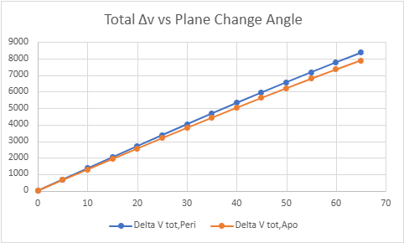
Figure 1: Total Δv as a function of plane change angle for maneuvers performed at periapsis and apoapsis.

Figure 1 shows that performing the plane change at apoapsis consistently requires less Δv than doing it at periapsis across all inclination angles. For example, at a 47° inclination change, the apoapsis maneuver requires about 346 m/s less Δv than the periapsis case.
Method
Assumptions
- Circular initial and final orbits
- Two-body Earth model (no drag, no perturbations)
- Impulsive burns

Orbital Velocities
$$v_{c}=\sqrt{\frac{μ}{r}}$$
Used to compute velocities in circular orbits, where $μ$is Earth’s gravitational parameter and $r$ is the orbital radius. Here, $μ=3.986×{10}^{14}\frac{ {\text{m}}^{3}}{{\text{s}}^{2}}$

Transfer Orbit (Vis-Viva)
$$v_{t}=\sqrt{μ\left(\frac{2}{r} − \frac{1}{a}\right)}$$
Used to find the velocity along the transfer orbit at different points, where $a$ is the semi-major axis of the transfer ellipse.

Hohmann Transfer Δv
$$Δv_{1}=v_{t,p}-v_{c1} \\ Δv_{2}=v_{c2}-v_{t,a}$$
These represent the two burns needed to enter and exit the transfer orbit, where $v_{c}$ is the circular velocity and $v_{t}$ is the transfer orbit velocity.

Plane Change Δv
$$Δv_{\text{plane}}=2vsin⁡\left(\frac{Δθ}{2}\right)$$
The plane change is evaluated at:
- periapsis ($v=v_{t,p}$)
- apoapsis ($v=v_{t,a}$)

Total Δv
$$Δv_{\text{total}}=Δv_{1}+Δv_{\text{plane}}+Δv_{2}$$
Example Calculation
To illustrate how the model works, a transfer from a 400 km orbit to an 800 km orbit with a 47° inclination change is considered. The corresponding orbital radii are $r_{1}=6.771×{10}^{6} \text{m}$ and $r_{2}=7.171×{10}^{6} \text{m}$, giving circular velocities of $v_{c1}=7672.6\text{ m/s}$and $v_{c2}=7455.5 \text{m/s}$, and transfer velocities of $v_{t,p}=7781.9 \text{m/s}$ and $v_{t,a}=7347.8 \text{m/s}$. Using these values, the total Δv is calculated for plane changes at periapsis and apoapsis. The apoapsis plane change results in a lower total Δv by approximately 346 m/s, consistent with the lower orbital velocity at that point. This result matches the trend shown in Figure 1.

Multi Target Comparison
Orbital Targets
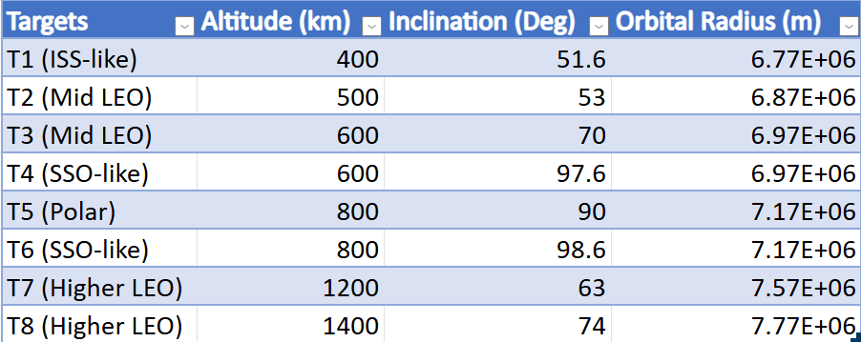
Figure 2: List of Orbital Targets used in Figure 3 listed from lowest orbit to highest.
Orbital Pair Δv Comparison
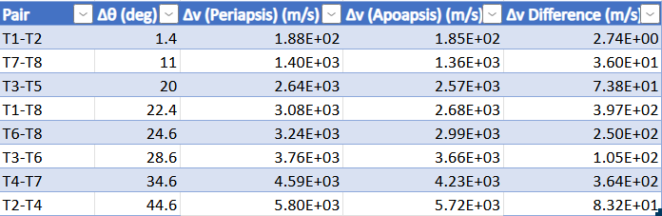
Figure 3: While the Δv difference generally increases with inclination change, it is also influenced by the difference in orbital radii, as smaller radius changes results in smaller velocity differences along the transfer orbit.

Conclusion
Performing the plane change at apoapsis consistently requires less total Δv than doing it at periapsis. This is because the spacecraft is moving slowest at apoapsis, and since the cost of a plane change depends on velocity, the maneuver becomes cheaper there. While the difference in Δv generally increases with the inclination change, the results also show that it depends on the difference in orbital radii, since smaller radius changes lead to smaller velocity differences along the transfer orbit. Overall, this highlights how important timing is when trying to minimize fuel in orbital transfers.

